NEWS FROM THE NAKIGAN’S

Beloved Brethren

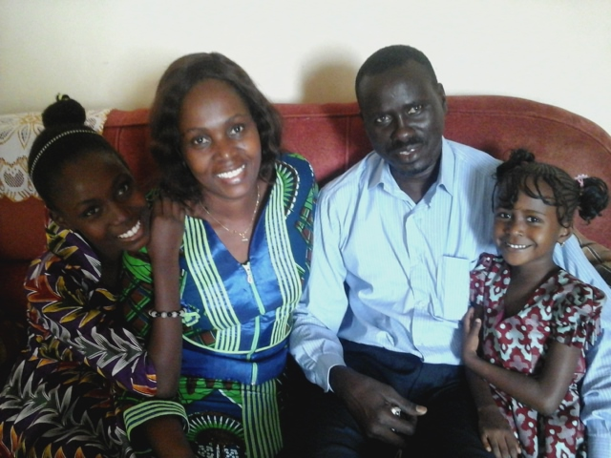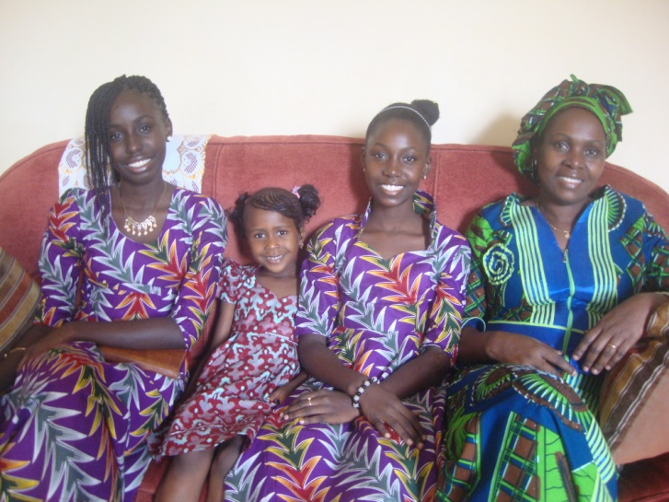

Happy new year.

We bring you greetings in the name of our Lord and savior Jesus Christ. Trusting that God's faithfulness will enable great things in righteousness this year again for his glory.
We thank you for standing with uplifted hands to Him with us over the years and we are indebted for the marvelous work God is doing in the Nations. We understand we cannot do it without Him and that's why we will never neglect getting you involved in this best ministry for this end times intercession. We appreciate you.
We’re thankful to God for His enabling grace to have worked with him in these past months and your supportive endeavors have made us fulfilled. You’re a virtue in the master’s hand to seeing this mission a reality.

MINISTRY NEWS

Our last news letter indicated all the events and programs carried out in the first half of to the year, and how the Lord made it possible.
New people joined the church, 3 couples in the church are blessed with babies, one wedding, it was just wonderful what the Lord did for us in 2015.
We began the year 2015 with many challenges, but in any steep God has shown mercy, we praise his name.
In August 28th, my wife Miriam and the Children went to Ziguinchor for some rest, but it was also an opportunity for us to do ministry in some Mankanya villages, under the rain some time. We have been able to give out 300 shoes boxes to children from five different villages (Boutoute, Kitor, Petit Camp, Kenya and Kansahoudy).
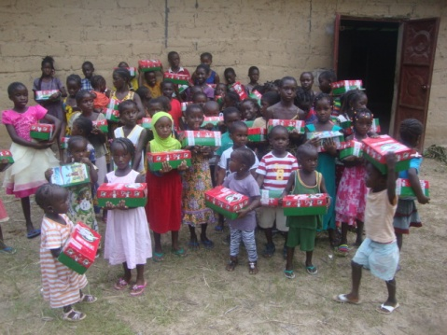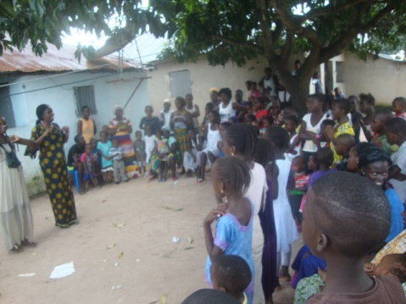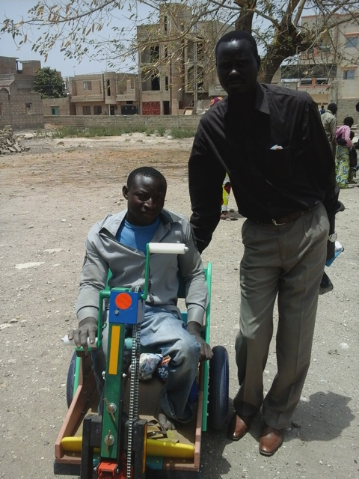

During the three weeks we stayed in Zig we had several meetings at Kansahoudy to shear the Gospel with our friends, and run radio programs on Wednesday evening and Sunday morning .We came back home September 18th.
A month after I was able to make it again (this November 17th to November 27^{th) ,}
for the tremendous changes and spiritual development he’s coming up with. This is giving us a hope for his future.
Our church is increasing in numbers by conversion but not without challenges many people are looking for job. Some families are really in need. . We have presently 6 candidates for water baptism this 3rd of junary.

PRAISE AND PRAYER

- Thank God for his faithful protection and provision during the year for us as a family.

- Pray God for the success of our mission trip to the south Senegal from January 18th to 28th . Pray that the prayer cells will be strong and vibrant.
- Pray for open doors among the MANKANYA people; many have heard the word of God, and we believe that our God want make them a people a real worshipers of the living God.
- Pray as the radio program is going every week that God will touched many listeners.
- Pray for passion about missions among the believers on in the church that the desire to be senders be re- ignited in the hearts of the members as well.
- Pray God to provide for the school project and health post.
- Pray for God’s protection over us as a family.

We appreciate your love for Mission

